ADSD HW4 ToDo Edit/Delete

Local Environment:

Edit:

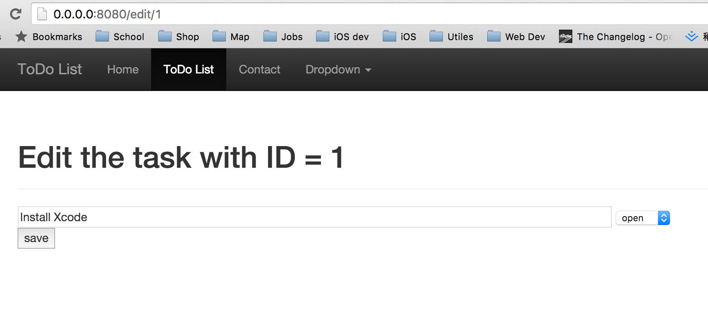

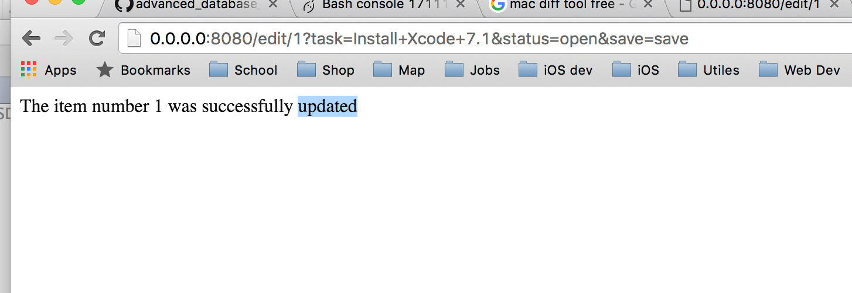

After Edit it :

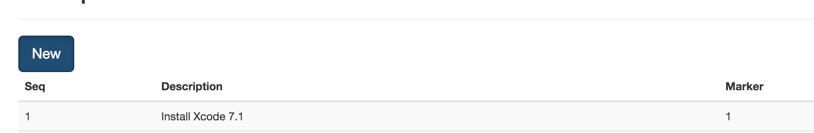

PythonAnywhere: (As same)

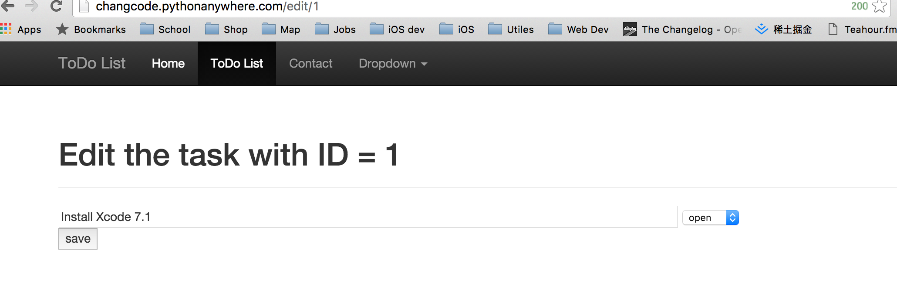

Local Delete:

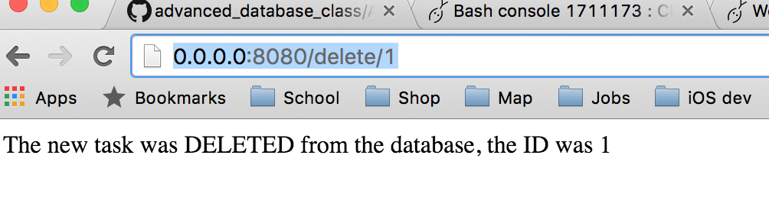

PythonAnywhere delete:

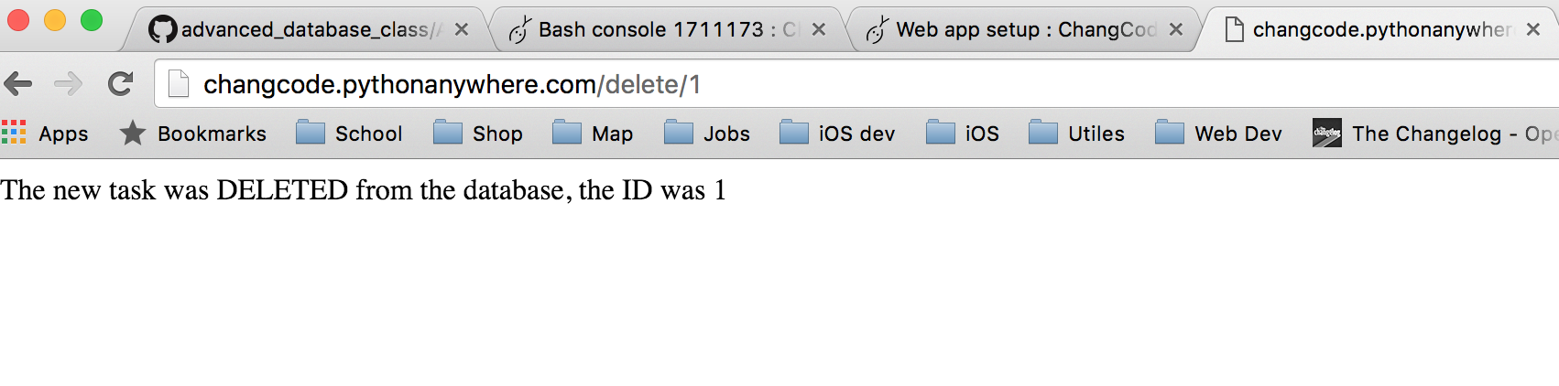

Code:

